**Studying All Night?**

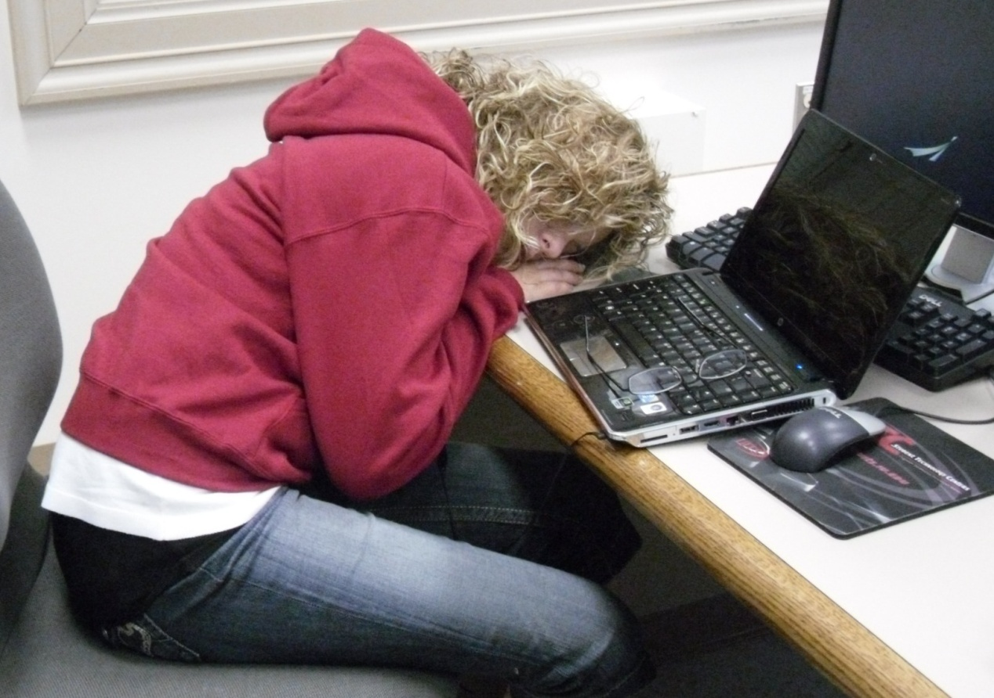

**LET US HELP YOU!** Our expert instructors teach effective study habits, time management skills, and energy-building techniques.

* Classes are $15.00 per session
* Sessions last four weeks
* Classes meet in the Student Services Center twice a week

**Call 555-2838 *or* stop by to sign up today!**